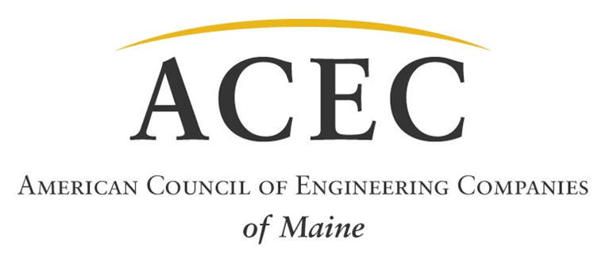
For immediate release:
ACEC of Maine
Maine Engineering Excellence Awards Announced
November 30, 2016

For additional information, contact Carolyn Bird at Casco Bay Engineering,
207-842-2800 or carolynb@cascobayengineering.com.

AUGUSTA - As a prelude to the national ACEC competition for the most innovative engineering projects in the country, ACEC of Maine announces their 2016 Engineering Excellence Awards. At this year's awards event, hosted at the University of Maine, six firms received recognition.

Grand Conceptor Award: Woodard & Curran for the Oxford Wastewater System

Woodard & Curran receives this year's top honor for its work with the Town of Oxford, Maine to design and build a new wastewater collection and treatment system. The Town hired Woodard & Curran as their Technical Design Engineering Consulting firm to help secure funding, perform permitting and design, and oversee construction of a state of the art treatment facility and sanitary sewer collection system. The facilities were built from the ground up to help promote economic activity and growth while serving to protect cherished environmental resources like the Little Androscoggin River. Previously failed systems had been linked to contamination of groundwater supplies and wells. The project improved the health, safety and welfare of the public as well as the surrounding environment. This project will meet the current and future needs of the Town of Oxford by providing a safe, efficient, and environmentally responsible way to manage the Town's wastewater. The system has the potential to help attract more economic growth to the region and with it, more jobs, which will help the rural town continue to building its vibrant community.

Special Recognition: Wright-Pierce for the Guiteras School

Wright-Pierce receives one of two Special Recognition Awards for Engineering Excellence for its work with Guiteras School. The Town of Bristol, RI received a Clean Water Act grant to address stormwater runoff of Canada geese waste pollution from the Guiteras School campus into Silver Creek, a coastal estuary draining into Rhode Island's Bristol Harbor. The water quality of the runoff from the site was improved by a design which integrated multiple, innovative stormwater treatment measures into the site redesign including strategically placed bioretention ponds and the planting of more than 1,000 native plants, all designed to provide filtration of stormwater accumulation on the site and to discourage Canada geese from occupying the lawn adjacent to the creek. Safety improvements on the elementary school campus were another positive feature of the design including new sidewalks, cross walks and improved traffic patterns.
Special Recognition: Haley & Aldrich, Inc. for the Martin Memorial Bridge Replacement

Haley & Aldrich, Inc. was awarded the second Special Recognition Award for Engineering Excellence for its work on the Martin Memorial Bridge Replacement in Rumford, Maine. Haley & Aldrich completed liquefaction susceptibility evaluations for the Maine Department of Transportation (MaineDOT) to determine the extent of liquefiable soils beneath the bridge. Based on the results of the initial evaluations as well as the approach embankment stability calculations, Haley & Aldrich concluded that large portions of the approach embankments were likely to fail during/after a seismic event. They judged that the most practicable liquefaction remedial alternative was vibro-replacement, and presented several alternatives for addressing the problem to MaineDOT. The ground improvement work began in October 2013 and was successfully completed in February 2014. This project represents the first time MaineDOT has used site-specific response and liquefaction susceptibility evaluations together with ground improvement techniques to mitigate liquefaction. Confirmatory test borings drilled within production ground improvement areas indicated that the minimum specified performance criteria were met or exceeded. The more complex technical evaluations resulted in the reduced likelihood of major adverse impacts to the bridge caused by future earthquake events, and saved the project an estimated $650,000 in construction costs.

Honor Award: GZA GeoEnvironmental, Inc. for Rock Stabilization for Bridge Reconstruction, State Route 125

Three Honor Awards for Engineering Excellence were also presented. The first was to GZA GeoEnvironmental, Inc. for its work as the geotechnical consultant for foundation design and rock stabilization for the State Route 125 Bridge Reconstruction project. The two-span structure that crosses the Androscoggin River had eroded the site down to bedrock with steep exposed ledges, undermined bedrock, and pinnacles. The primary design challenges were to stabilize the undermined rock to prevent additional rockfall that could jeopardize support of the new abutment, and to reinforce the bedrock pinnacle to prevent a sliding failure in the bedrock beneath the new foundation. After conducting test borings with geophysical logging and surface bedrock mapping, geologic field mapping of bedrock outcrops, and field investigation and analyses, GZA determined that the combination of adverse geology and prior river modifications made foundation support for this project unusual and more complex. GZA developed a unique concrete buttress which would fill the cavity and protect the abutment foundation from undermining, as well as vertical shear dowels to reinforce the rock mass.

Honor Award: CES, Inc. for Schoodic Woods

CES was named the recipient of a second Honor Award for work on the new Schoodic Woods facility in Acadia National Park. CES' services to the Schoodic Woods Project including survey, natural resources mapping, civil engineering design of trails, campus site, parking, water supply, treatment and distribution system, location and development of groundwater wells, Local, State, and Federal permitting, conservation easement negotiations, and construction assistance. The initial goal during concept planning was to have the Schoodic Woods campground and development open to coincide with the National Park Service centennial in the summer of 2016. CES' team of dedicated design professionals, along with the National Park Service and its General Contractor, was able to deliver this monumental project a year ahead of schedule and under budget. A key result of the project was the set aside of a conservation easement that stipulated the undeveloped portion of the project will always remain as such. The project met land development standards resulting in very minimal impact to the landscape. Innovative technologies for stormwater treatment were utilized to minimize the footprint and resulting visual impacts to visitors of the facility.

Honor Award: Amec Foster Wheeler Environment & Infrastructure for Fore River Seep Remediation

Amec Foster Wheeler Environment and Infrastructure, Inc. is the third recipient of an Honor Award for its successful design and implementation of a remedy to legacy environmental impacts associated with the former Portland Gas Works manufactured gas plant site located adjacent to the Fore River in Portland, Maine. The remedial objective negotiated under the Maine Department of Environmental Protection Voluntary Response Action Program was to eliminate sheen along the Fore River intertidal zone caused by sediments impacted by purifier box wastes and coal tar distillates. The project required a combination of remedies be implemented under the operational constraints inherent to shoreline sediment removal in a busy marine port, including a passive containment system that combined a 250 foot long barrier wall, a secondary AquaBlok® vertical barrier, and AquaBlok® cap to prevent migration of coal tar to the river; excavation of contaminated soil and sediment behind an engineered turbidity/fish exclusion barrier; and restoration of the riverbank. Impacted soil and sediment was excavated, transported off-site, and recycled for beneficial reuse as road base material rather than occupying valuable space in a landfill.

The American Council of Engineering Companies congratulates and thanks these engineering firms for their continuing efforts to improve, innovate and design our built environment.

***

