**FIRM**

**COVID19 WORKPLACE PREVENTION AND REPONSE POLICY**

The purpose of this policy is to prevent and respond to workplace exposures to COVID19 while continuing our essential business functions during an outbreak. FIRM is prepared to change our business practices, if needed, to maintain critical operations to meet the needs of our clients. Per guidance from the Cybersecurity and Infrastructure Agency (CISA), our industry services are deemed essential critical infrastructure.

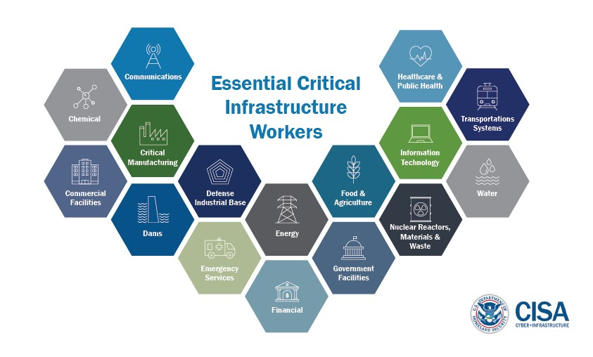

Following Centers for Disease Control (CDC), federal Occupational Safety and Health

Administration (OSHA) and the U.S. Equal Opportunity Employment Commission (EEOC) guidelines, the following FIRM policy covers the prevention of COVID19 and the FIRM’S policy for responding to employees who are ill with COVID-19 symptoms or employees who live with a person who is diagnosed or suffering from COVID-19 symptoms.

FIRM has a designated COVID19 Workplace Coordinator to handle COVID19 questions. Sick employees are advised to contact the coordinator, in addition to their supervisor, if they have been diagnosed with COVID-19, they are exhibiting symptoms or who have a sick family member at home with COVID-19:

# NAME Title Contact information

## MAINTAINING A HEALTHY WORKSITE

**FIRM encourages all sick employees to stay home.**

Employees are advised to follow CDC recommended steps to protect themselves from COVID19 at work and at home. FIRM has placed CDC guidance throughout the office for those working on-site. [https://www.cdc.gov/coronavirus/2019-ncov/downloads/stopthe-spread-of-germs.pdf](https://www.cdc.gov/coronavirus/2019-ncov/downloads/stop-the-spread-of-germs.pdf) and provided all employees the attached CDC guidance on preventing the spread of COVID19. (ATTACHMENT #1).

FIRM has instituted the following workplace adjustments to minimize the spread of COVID19 during an outbreak:

* FIRM performs routine environmental cleaning and disinfection of all frequently touched surfaces in the workplace, such as workstations, keyboards, telephones, handrails, and doorknobs.
* FIRM provides tissues and no-touch disposal receptacles.
* All employees are required to frequently wash their hands with soap and water. FIRM maintains soap and water in the workplace and, as available, FIRM maintains alcohol-based hand sanitizer that is at least 60% alcohol in multiple locations.
* During a COVID19 outbreak FIRM discourages handshaking and encourages the use of other noncontact methods of greeting.
* All FIRM employees are discouraged from using other workers’ phones, desks, offices, or other work tools and equipment, when possible. If necessary, employees are directed to clean and disinfect them before and after use.
* FIRM provides disposable wipes so that commonly used surfaces (for example, doorknobs, keyboards, remote controls, desks, other work tools and equipment) can be wiped down by employees before each use.
* All employees present at the office are required to maintain at least six feet of distance between each other. FIRM may relocate employees within the office to ensure a safe distance is maintained.
* FIRM has established remote meeting options for those who are required to participate in scheduled calls and meetings. Employees should consult with their supervisor for more information.
* FIRM may limit or prohibit visitors to the office beyond authorized personnel during the COVID19 outbreak. If any non-authorized personnel are allowed into the building, all CDC recommended protocols will be followed.
* FIRM will perform enhanced cleaning and disinfection after persons suspected/confirmed to have COVID-19 have been in the facility following CDC guidelines.

## LEAVE POLICIES DURING COVID19

FIRM prioritizes the health and well-being of our employees. FIRM will monitor all absenteeism and requests for leave during a COVID19 outbreak. FIRM will approve paid and unpaid leave as appropriate and in consideration of current leave policies and will adhere to all local, state and federal requirements.

At the discretion of FIRM, employees may have their work schedules altered to reduce the number of employees physically present at the office.

Where feasible and with approval of an employee’s supervisor, employees may be granted approval to work from home. The supervisor will work with the employee to develop a weekly work plan and will evaluate the productivity of the employee regularly to ensure all project schedules are maintained.

All employees are advised to contact the FIRM COVID19 Workplace Coordinator and their supervisor if they have circumstances that prohibit them from maintaining their work schedules including a child who is dismissed from school or childcare; the employee is suffering from symptoms of COVID19; or the employee lives with someone diagnosed or suffering from the symptoms of COVID19.

To protect the workplace and all firm employees, FIRM may send an employee home who is exhibiting symptoms of COVID19.

FIRM has posted and emailed employees the Families First Coronavirus Response Act notification for employees. (Attached)

## EMPLOYEES AUTORIZED TO TRAVEL DURING COVID19 OUTBREAK

Only travel that is deemed absolutely necessary will be approved. No employee shall travel without express written permission from their supervisor.

If approved, an employee authorized to travel for business is advised to check themselves for symptoms of COVID-19 (i.e., fever, cough, or shortness of breath) before starting travel and notify the COVID19 Workplace Coordinator and their supervisor and stay home if they are sick.

In lieu of travel, a supervisor may require:

* videoconferencing or teleconferencing when possible for work-related meetings and gatherings.
* canceling, adjusting, or postponing work-related meetings or gatherings that can only occur in-person.
* meetings be held in open, well-ventilated spaces.

Employees who become sick while traveling or on temporary assignment must notify the firm COVID19 Workplace Coordinator, their supervisor and promptly call a healthcare provider for advice if needed.

**EMPLOYEES WITH SUSPECTED OR CONFIRMED CASES OF COVID-**

**19**

Employees who have [symptoms](https://www.cdc.gov/coronavirus/2019-ncov/about/symptoms.html) (i.e., fever, cough, or shortness of breath) are instructed to notify their supervisor and the COVID-19 Workplace Coordinator and to stay home.

Employees are asked to[follow the Centers for Disease Control (CDC) recommended steps](https://www.cdc.gov/coronavirus/2019-ncov/downloads/sick-with-2019-nCoV-fact-sheet.pdf) for sick employees.

Employees who are well but who have a sick family member at home with COVID-19 are instructed to notify their supervisor, the COVID-19 Workplace Coordinator and stay home. Employees are asked to follow [CDC recommended precautions.](https://www.cdc.gov/coronavirus/2019-ncov/hcp/guidance-prevent-spread.html#precautions)

Employees who appear to have symptoms (i.e., fever, cough, or shortness of breath) upon arrival at work or who become sick during the day will be immediately separated from other employees, customers, and visitors and sent home.

Employees are instructed not to return to work until the criteria to discontinue home isolation are met, in consultation with healthcare providers and state and local health departments as follows:

Employees **with COVID-19 who have stayed home (home isolated) are advised they** can stop home isolation under the following conditions:

* ***If you will not have a test***to determine if you are still contagious, you can return to work after these three things have happened:
  + You have had no fever for at least 72 hours (that is three full days of no fever without the use medicine that reduces fevers)

AND

* + other symptoms have improved (for example, when your cough or shortness of breath have improved) AND
  + at least 7 days have passed since your symptoms first appeared
* *If you will be tested* to determine if you are still contagious, you can return to work after these three things have happened:
  + At least 14 days from positive test notification; and
  + You no longer have a fever (without the use medicine that reduces fevers)

AND

* + other symptoms have improved (for example, when your cough or shortness of breath have improved)

AND, if available, you received two negative tests in a row, 24 hours apart. Your doctor will follow [CDC guidelines.](https://www.cdc.gov/coronavirus/2019-ncov/hcp/disposition-in-home-patients.html)

• Employees in all cases are instructed to **follow the guidance of their healthcare provider and local health department.** The decision to stop home isolation should be made in consultation with your healthcare provider and state and local health departments.

If a FIRM employee is confirmed to have COVID-19 infection, FIRM will inform fellow employees of their possible exposure to COVID-19 in the workplace but will maintain confidentiality as required by the Americans with Disabilities Act (ADA). All FIRM employees will be instructed to then self-monitor for symptoms (i.e., fever, cough, or shortness of breath).

CONFIDENTIALITY: *Due to federal ADA requirements employee* ***names and conditions will not be disclosed to fellow FIRM employees. However, fellow FIRM employees will be notified about their possible exposure to COVID-19 in the workplace and advised to follow*** [*CDC precautions*](https://www.cdc.gov/coronavirus/2019-ncov/prepare/prevention.html)***to protect themselves and monitor for symptoms.***

## Resources of information

* [Centers for Disease Control (CDC).](https://www.cdc.gov/coronavirus/2019-ncov/community/guidance-business-response.html)
* Occupational Safety and Health Administration [OSHA.](https://www.osha.gov/Publications/OSHA3990.pdf)
* U.S. Equal Employment Opportunity Commission [EEOC](https://www.eeoc.gov/eeoc/newsroom/wysk/wysk_ada_rehabilitaion_act_coronavirus.cfm)
* [COVID-19 Website](https://www.cdc.gov/coronavirus/2019-ncov/index.html)
* [What You Need to Know About COVID-19pdf icon](https://www.cdc.gov/coronavirus/2019-ncov/downloads/2019-ncov-factsheet.pdf)
* [What to Do If You Are Sick With COVID-19pdf icon](https://www.cdc.gov/coronavirus/2019-ncov/downloads/sick-with-2019-nCoV-fact-sheet.pdf)
* [Interim US Guidance for Risk Assessment and Public Health Management of](https://www.cdc.gov/coronavirus/2019-ncov/php/risk-assessment.html)

[Persons with Potential Coronavirus Disease 2019 (COVID-19) Exposure in Travel-associated or Community Settings](https://www.cdc.gov/coronavirus/2019-ncov/php/risk-assessment.html)

* [Small Business International Travel Resource Travel Plannerpdf icon](https://www.cdc.gov/niosh/docs/2019-165/pdfs/2019-165.pdf?id=10.26616/NIOSHPUB2019165)
* [Persons at Higher Risk of Severe Illness](https://www.cdc.gov/coronavirus/2019-ncov/need-extra-precautions/people-at-higher-risk.html)